**Assignment 1 – Assembly Analyzing and Basic C# Programing**

**Raz Ashtar – 307851311 Sahar Tirosh – 316125004**

**Part A: Sherlock Holmes**

1. Is Ex01.exe a .NET Assembly? כן

Is Ex01.exe a .NET PE? כן

Please provide a short explanation that supports your answers:

הקובץ הוא .NET Assembly כי אפשר לפתוח אותו עם ה-ILDASM שהוא כלי לניתוח אסמבלי.

הקובץ הוא .NET PE כי הוא קובץ executable ו - .NET Assembly

Please provide the following info about the Assembly which is contained in Ex01.exe

a. Name: ______B22_Ex01__________

b. Version: _____22:2:1:20395_______

c. In which section in the assembly you can find the answers to the previous questions (a, b)? _____Manifest_______

d. Which assemblies are being referenced by this assembly?

Name: _____mscorlib_______ Version: _____4:0:0:0_____

Name: _____System.xml_____ Version: _____4:0:0:0_____

|  |  |  |
| --- | --- | --- |
| **Members (methods, fields)** | **Name** | **Type** (Struct/Class/Enum) |
| * Public void .ctor() * Public static void RunMenu() * Private static bool manageLogin() * Private static eMenuOptions retrieveUserSelection() * Private static void showOption() | DemosManager | Class |
| * Public void .ctor() * Public static void RunAstrixClock() * Public static void RunBinaryAnalyzer() * Private static bool checkIfAscendingSeries(string i_NumberStr) * Private static bool checkIfDescendingSeries(string i_NumberStr) * Private static void drawClock(int32 i_NumOfLines) * Private static int32 generateLineOfAstrix(class [mscorlib]System.text.stringBuilder i_SB, int32 i_PlaceInText, int32 i_Rows) * Private static string getInputFromUser([out] int32& o_CrrentNumber) | DemoApps | Class |
| * public static literal valuetype Abort * public static literal valuetype AstrixClock * public static literal valuetype BinaryAnalyzer * public specialname rtspecialname int32 value__ | eMenuOptions | Enum |
| * Public void .ctor() * Public static void Main() | Program | Class |

1. Username: CSharp.NET

Password: isdebest

**Part B – Basic C# Programing**

**ScreenShots:**

דוגמאות הרצה - שאלה 1:

דוגמאות הרצה – שאלה 2:

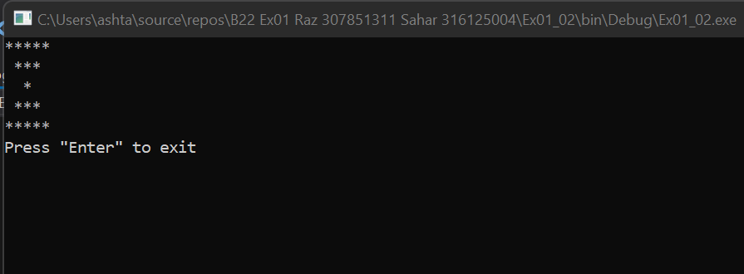

דוגמאות הרצה - שאלה 3:

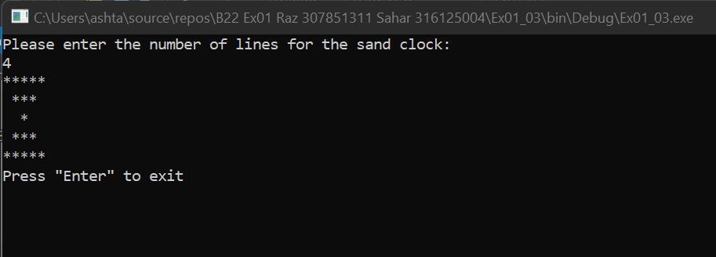

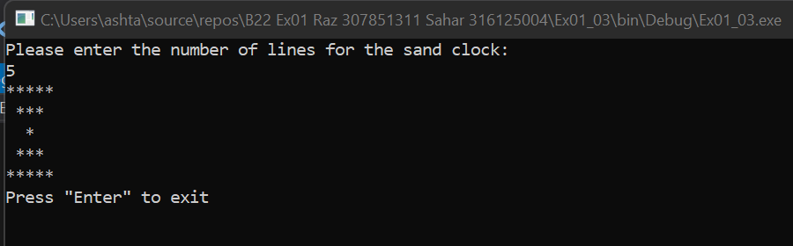

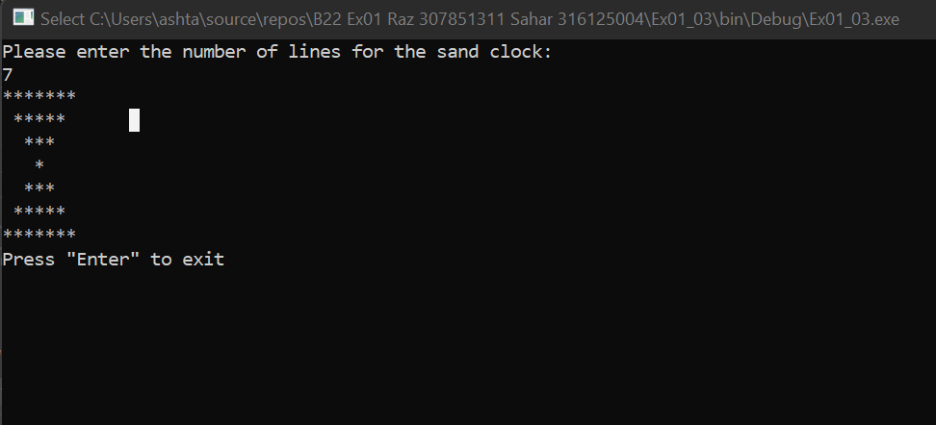

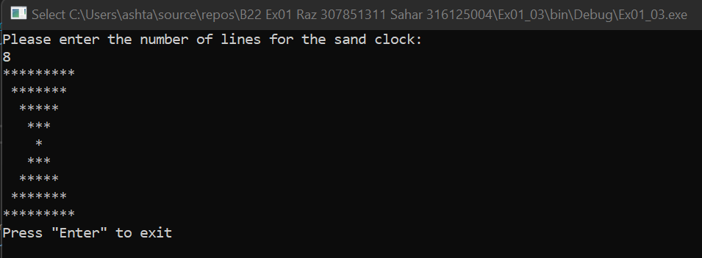

דוגמאות הרצה - שאלה 4:

דוגמאות הרצה - שאלה 5: